**Microprocessor Lab**

Laboratory Activity No. 1

**Familiarization with TinkerCAD**

|  |
| --- |
|  |

Score

*Submitted by:*

**Peralta, Jerome Michael C.**

**S 10:00AM – 11:30AM / 412.1-1**

*Date Submitted*

**17-09-2023**

*Submitted to:*

**Engr. Maria Rizette H. Sayo**

1. Exercise

a. A process in Tinkercad where we can develop electronic circuits that can be quickly updated, modified, and tested is called prototyping.

b. In Tinkercad, ‘Start’/’Stop’ Simulation tests the working of the circuits and the components.

c. The device used to assemble and connect the various components is known as breadboard.

d. In an electronic circuit with LED, the positive end of the circuit should be connected to the anode and negative end should be connected to cathode of the LED.

e. A resistor is used to restrict the flow of current to electrical components.

2. Label the following:



1. Anode and Cathode in a LED



Cathode

Anode

1. Different parts of breadboard

Power Rails

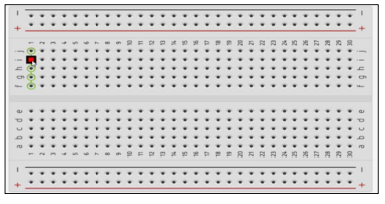

DIP Support

Terminal Strips

1. List the electronic components used in a circuit assembly.

Basic Components:

1. Resistor
2. LED
3. Pushbutton
4. Potentiometer
5. Capacitor
6. Slideswitch
7. 9V Battery
8. Coin Cell 3V Battery
9. 1.5V Battery
10. Breadboard
11. Micro:bit
12. Arduino Uno R3
13. Vibration Motor
14. DC Motor
15. Micro Servo
16. Hobby Gearmotor
17. NPN Transistor (BJT)
18. LED RGB
19. Diode
20. Photoresistor
21. Soil Moisture Sensor
22. Ultrasonic Distance Sensor
23. PIR Sensor
24. Piezo
25. Temperature Sensor
26. Multimeter